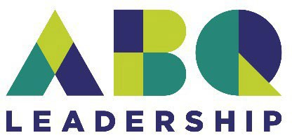  CLASS OF 2026-2027 APPLICATION | Program Timeline:  June 1, 2026 – General Application phase opens August 1, 2026 – Application phase closes August 15, 2026 – Acceptance notifications sent September 26, 2026 – Tuition due  September 2026 - April 2027 – Program Days April 2027 – Graduation Ceremony
APPLICANT INFORMATION
Name (first & last): | Job Title: | Years at position?
Employer: | Business Address:
City/State/Zip: | Personal Mailing Address:
Polo Shirt Size: | Your Email:
Phone (w): | Phone (c):
Immediate Supervisor: | Immediate Supervisor Phone and Email:
EMERGENCY CONTACTS
Name: | Phone:
Name: | Phone:
LEADERSHIP & COMMUNITY INVOLVEMENT
Please provide short answers to the following questions, by typing your answers below:

- Describe the nature of your current professional leadership role and any past leadership experience you have.

- What specific skills or knowledge do you hope to gain from Leadership Albuquerque?

- Describe one of the challenges you believe Albuquerque and/or New Mexico faces that inhibits economic growth in our community.

Guidelines for Commitment:
Attendance at program days is necessary to receive a meaningful Leadership Albuquerque experience. Additionally, participation and engagement with our speakers and the other members of the cohort is highly encouraged. It is understandable that, on occasion, an absence from a program day is unavoidable; however, except in extraordinary circumstances, if a participant misses more than two class days, they will not be eligible for graduation. The Chamber’s Leadership Albuquerque team will work to notify the class of program dates with as much notice as possible (typically four weeks, more in some cases).

Applicant Commitment: If selected to participate in the Leadership Albuquerque Class of 2026-2027 I will devote the time required to attend all events and sessions within the program. I understand my attendance and preparedness are mandatory and that if I fail to meet the obligations of the program, I will be disenrolled from the program with no tuition refund.

I have support from my supervisor/employer to participate. My supervisor(s) understand that my participation in Leadership Albuquerque means I will be out of the office for a full day approximately once per month.
Participant Signature: Date:

(Print and sign, or type name to indicate agreement)
APPLICATION CHECKLIST
- Application form completed
- Leadership & Community Involvement Questions completed
- Résumé attached
- Employer/Organization letter of recommendation & support attached (for self-employed applicants, please submit a letter of recommendation from a community member showing their support of your participation in Leadership Albuquerque)
- Noted other timeline prerequisites and important dates
Return completed applications with attachments to: D’Val Westphal | dwestphal@greaterabq.com





LEADERSHIP ALBUQUERQUE IS SPONSORED BY:



